# CS 255 System Design Document

## UML Diagrams

### UML Use Case Diagram

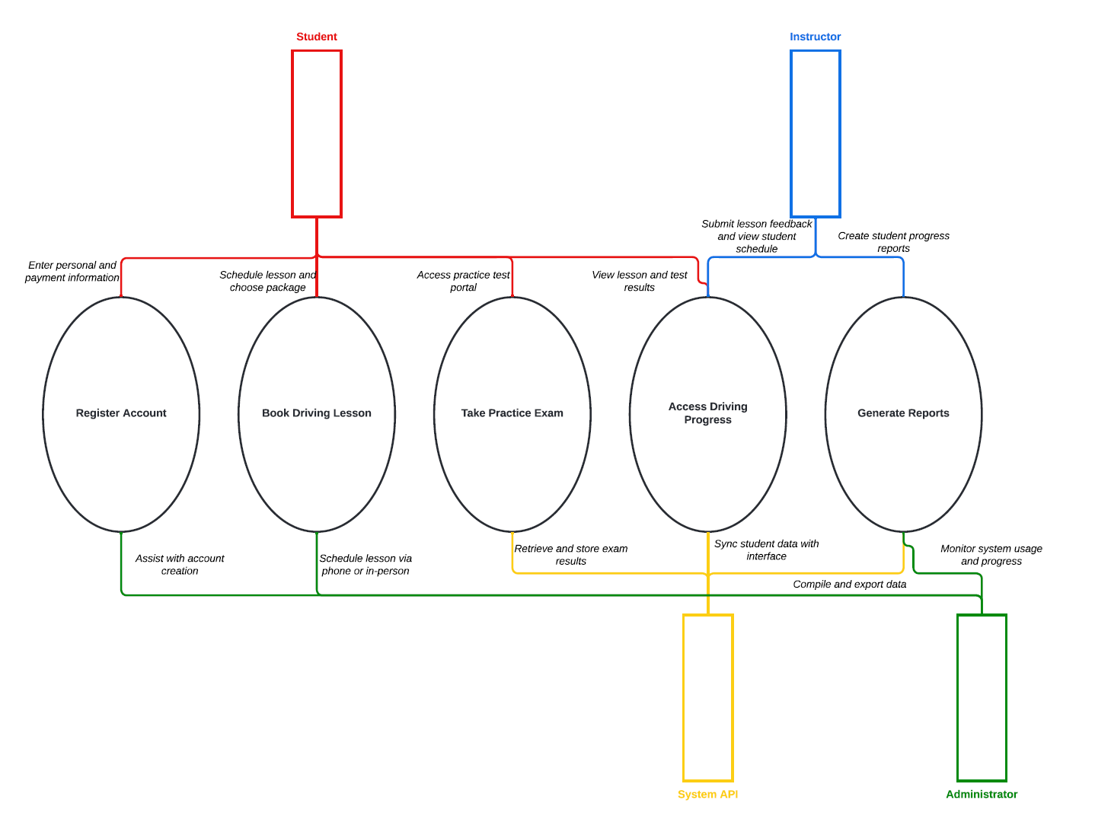

### UML Activity Diagrams

**Register Account Book Driving Lesson**

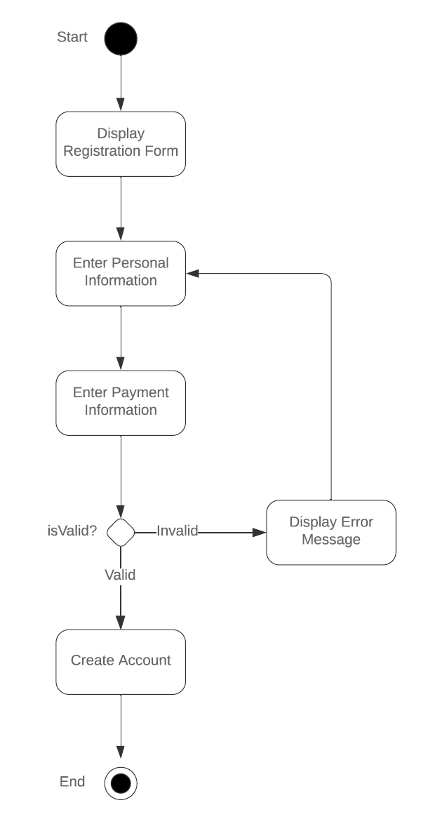 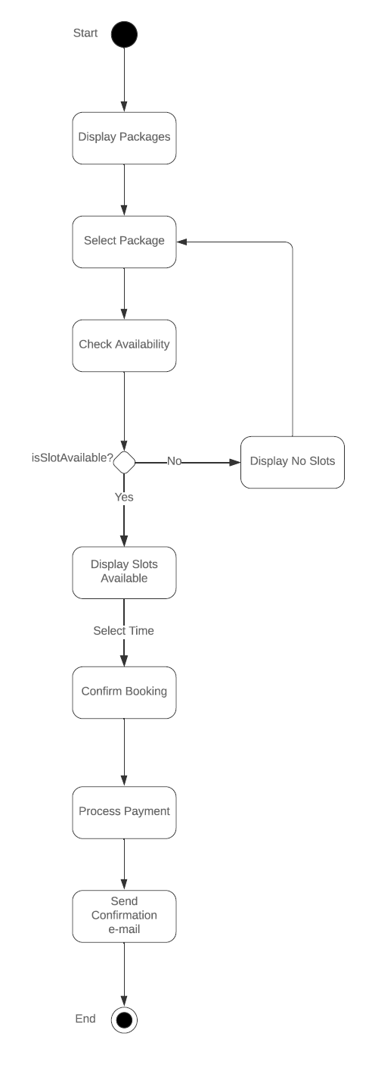

### UML Sequence Diagram

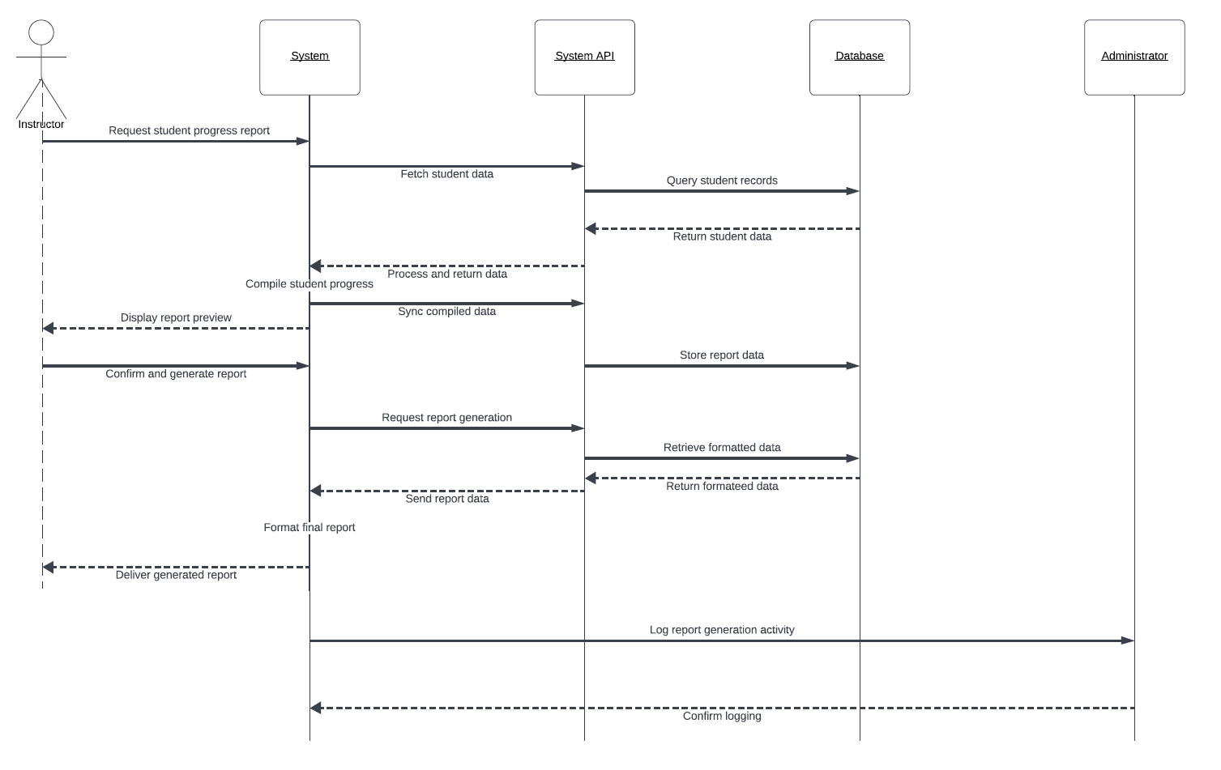

### UML Class Diagram

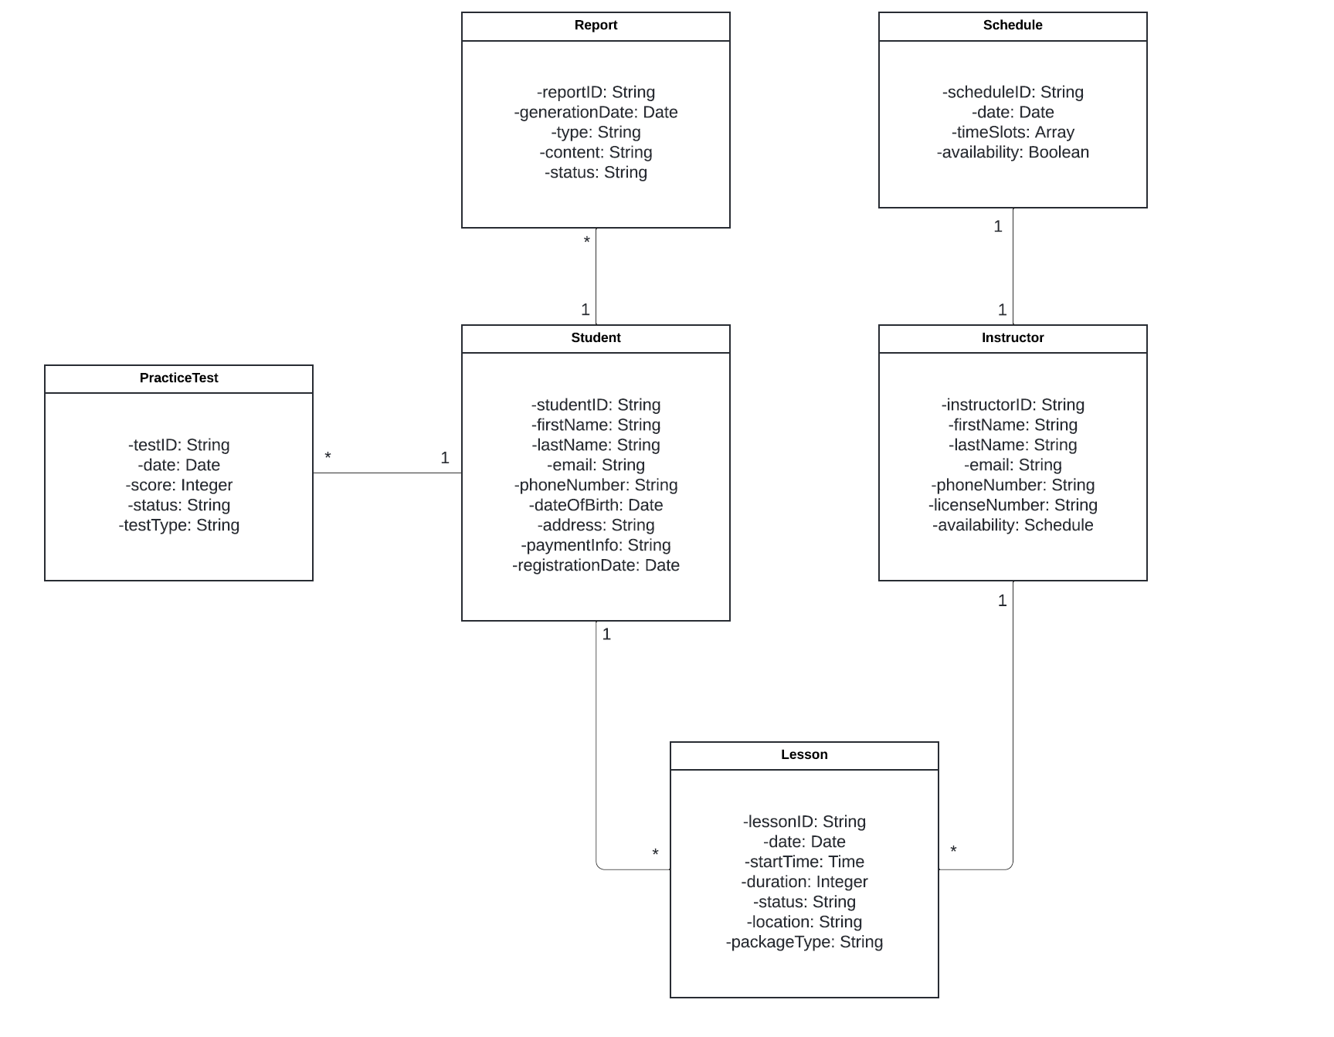

## Technical Requirements

To make the DriverPass system work properly, we need a mix of hardware, software, tools, and infrastructure.

1. **Hardware:**

* Servers: To host the system and store all data like user accounts, test results, and reports.
* Devices: Computers, laptops, or phones with internet access so students, instructors, and admins can use the system.
* Storage: Enough space to save profiles, test results, schedules, and reports.

1. **Software:**

* Operating System: Reliable systems like Linux or Windows for the servers.
* Database: Something like MySQL or PostgreSQL to store and manage data.
* Web Server: Apache or NGINX to host the web app.
* Development Tools:
  + Back-End: Java (Spring Boot) to handle all the system processes.
  + Front-End: HTML, CSS, and JavaScript (React or Angular) to create an easy to use interface.
  + APIs: For connecting to systems like the DMV to sync schedules and policies.

1. **Tools:**

* Diagram Tools: Lucidchart for creating system diagrams.
* Version Control: GitHub for managing code and team collaboration.
* Testing: Postman for API testing and tools like Selenium for testing the user interface.

1. **Infrastructure:**

* Cloud Hosting: AWS or similar services to keep the system running smoothly.
* Internet: A stable connection to allow real-time updates between users and the system.
* Security:
  + Role-based access to make sure only authorized users can see certain data.
  + Encryption to protect sensitive info like payment details.
  + Firewall and antivirus software to keep the system safe.